Vi-soft – MONITORING LAB RESULTS ASSIGN

# oN-GOING PROCESS

TO check the ongoing situation, global Admin must log in into the system and use following menu:

# 

Under this menu, the whole process log is introduced

There are 2 sub screens on the screen below:

One is for File Transfer (transferring files between FTP to the production server)

For example

# 

To see the list of files that were received from one lab, one can filter by username

# 

Also, for search, the search window can be used

Second sub screen for this interface is the assign process log, showing also the details of inserting the results into the system

Report region looks as following:

# 

When pressing on the editing option on the report, we see the details of XML’s parsing

# 

# EXCEL report

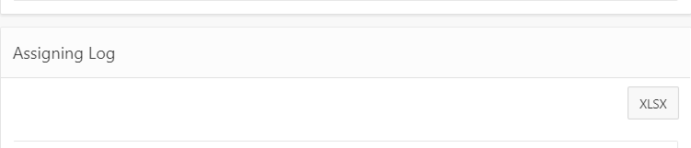

# Statuses

## Problems with PDF:

“The PDF file error: incorrect file name” (format of PDF file was wrong)

“The PDF file error: unknown order id” (order id that was on PDF file is wrong)

## Problems with XML:

“The XML file error: unknown order id” (order id in XML file is wrong)

“The XML file error: file structure is damaged or incorrect” (probably this file is not XML format)

“The XML file error: incorrect count of results” (in case when not all external codes are arrived inside an XML)